Dependency Injection

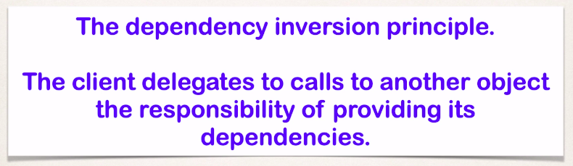

Suppose we want a car to be specially built. So, we will talk to the mechanics at the factory about our requirement and they are the assemblers hence they will build the car and will deliver to us eventually.

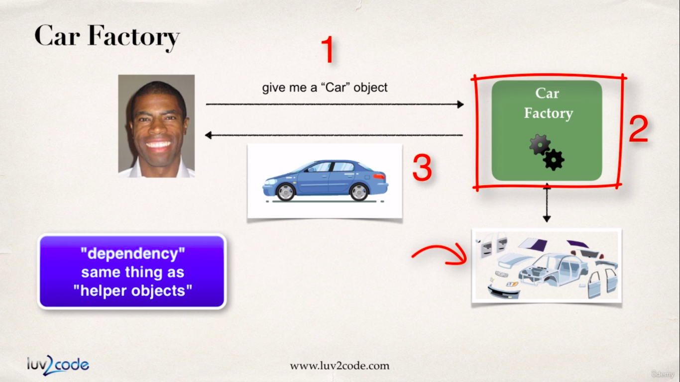

In the spring world we had a bean/object factory where with the help of config files we were able to fetch beans on demand. This bean we fetch on demand may further dependency on other objects for proper functioning.

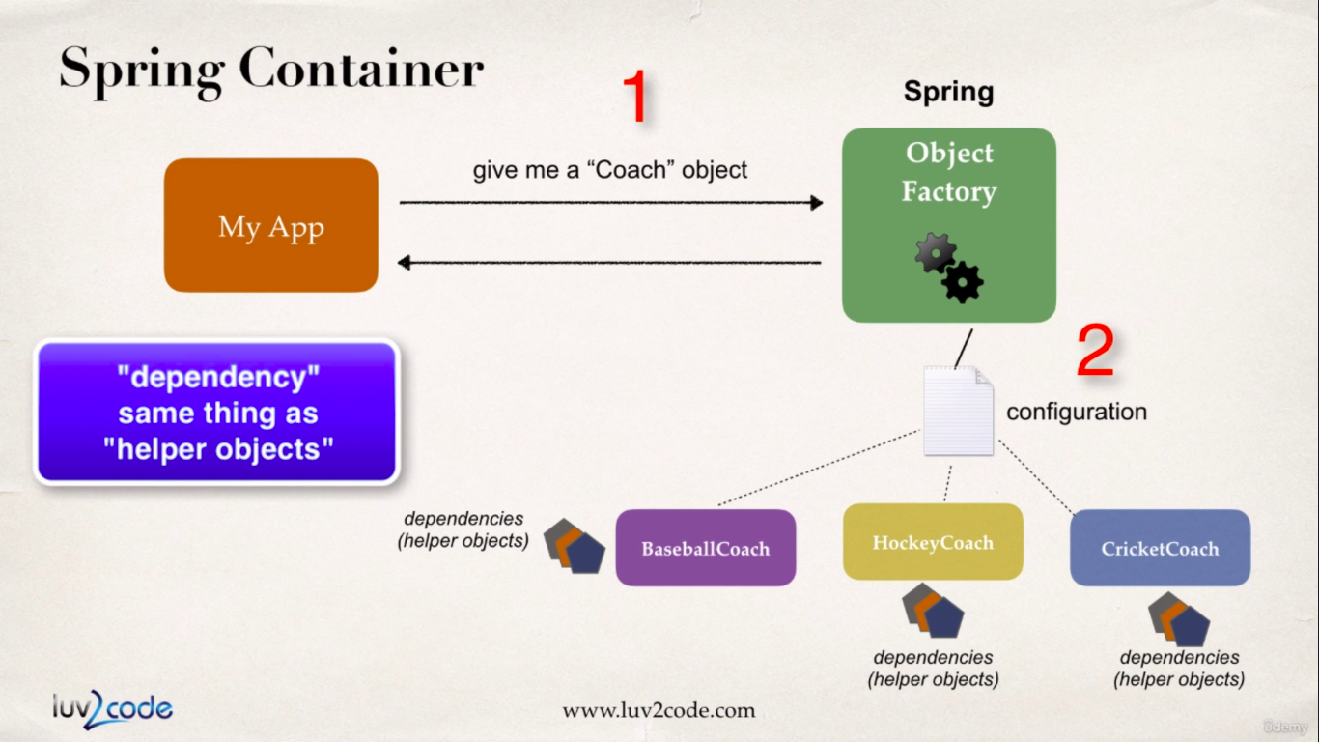

So spring framework will help us fetching the object in demand plus it will create all the dependency objects by itself.

Previously we have seen the spring container’s function of creating and managing beans/objects, which is also known as **inversion of control**.

Now we will see the other job which is its ability to inject bean’s dependencies which is also known as **dependency injection.**

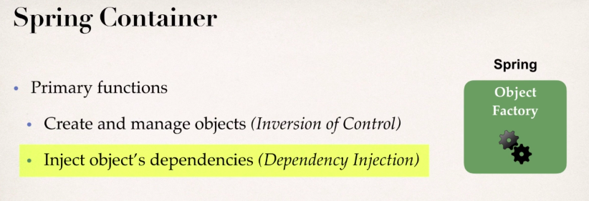

Up until in our course we have written a logic where we call ‘getDailyWorkOut()’ to get daily workout routine. Now the ‘Coach’ interface will also provide

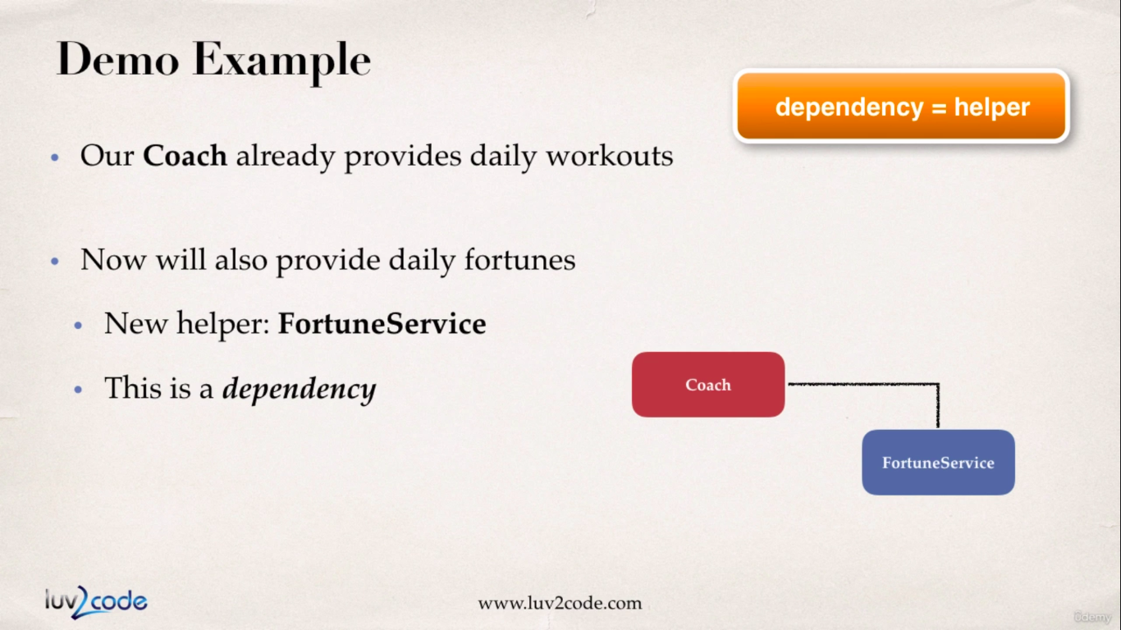

Injection Types in Spring

We will cover the most used injection types in this course. Those are,

1. Constructor Injection
2. Setter Injection

We will also see “auto-wiring” in the annotations section.

Constructor Injection

**Development Process (constructor Injection):**

1. Define the dependency Interface and class.
2. Create a constructor in our class for injection.
3. Configuring the dependency in the spring configuration file, consider the image below,

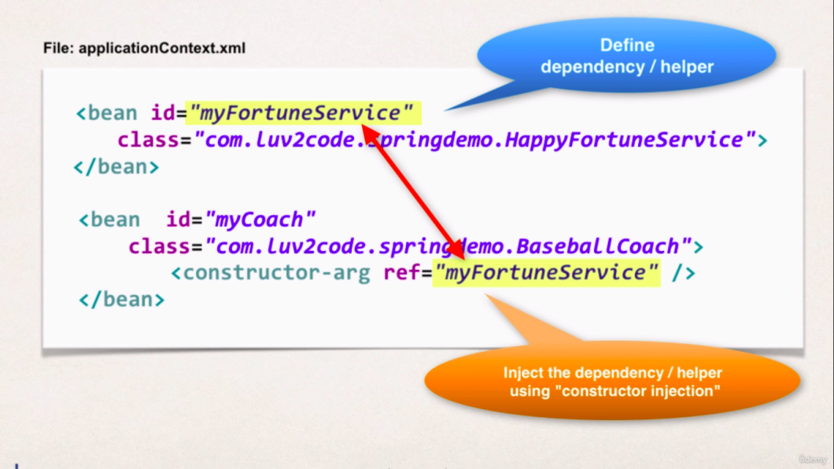

So in an actual execution scenario when spring goes through our config.xml file it will invoke the constructor of ‘BaseBallCoach’ class and with the constructor-injector-ref-token it will retrieve the object of the fortune service.

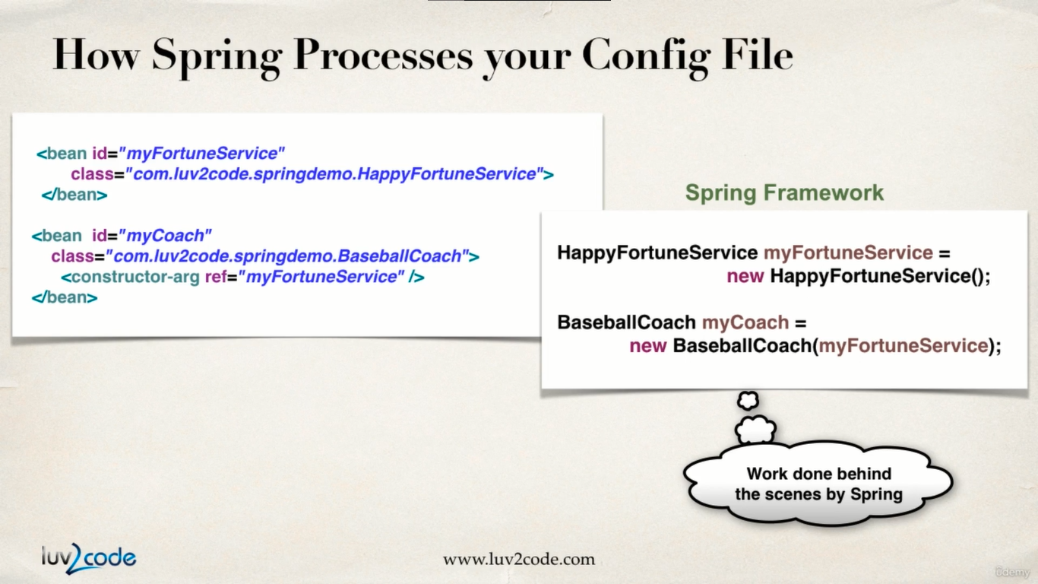

Consider the code below which depicts the above steps :

**applicationContext.xml**

<?xml version=*"1.0"* encoding=*"UTF-8"*?>

<beans xmlns=*"http://www.springframework.org/schema/beans"*

xmlns:xsi=*"http://www.w3.org/2001/XMLSchema-instance"*

xmlns:context=*"http://www.springframework.org/schema/context"*

xsi:schemaLocation=*"http://www.springframework.org/schema/beans*

*http://www.springframework.org/schema/beans/spring-beans.xsd*

*http://www.springframework.org/schema/context*

*http://www.springframework.org/schema/context/spring-context.xsd"*>

<!-- Define your beans here -->

<bean id=*"myCoach"* class=*"com.busybox.springdemo.TrackCoach"*>

<!-- setup constructor injection -->

<constructor-arg ref=*"myFortuneBean"*></constructor-arg>

</bean>

<bean id=*"baseBallCoach"*

class=*"com.busybox.springdemo.BaseBallCoach"*>

<!-- setup constructor injection -->

<constructor-arg ref=*"myFortuneBean"*></constructor-arg>

</bean>

<!-- dependency bean -->

<bean id=*"myFortuneBean"*

class=*"com.busybox.springdemo.HappyFortuneService"*></bean>

</beans>

**FortuneService.java (service interface)**

**package** com.busybox.springdemo;

**public** **interface** FortuneService {

**public** String getFortune();

}

**FortuneServiceImpl.java (service impl class)**

**package** com.busybox.springdemo;

**public** **class** HappyFortuneService **implements** FortuneService {

@Override

**public** String getFortune() {

**return** "today is your lucky day";

}

}

**BaseballCoach.java**

**package** com.busybox.springdemo;

**public** **class** BaseBallCoach **implements** Coach {

// define a private field for dependency

**private** FortuneService fortuneService;

// define a constructor for dependency injection

**public** BaseBallCoach(FortuneService fortuneService) {

**this**.fortuneService = fortuneService;

}

@Override

**public** String getDailyWorkout() {

**return** "spend 30 minutes in batting practice";

}

@Override

**public** String getDailyFortune() {

// use the fortuneService to get fortune

**return** **this**.fortuneService.getFortune();

}

}

**TrackCoach.java**

**package** com.busybox.springdemo;

**public** **class** TrackCoach **implements** Coach {

**private** FortuneService fortuneService;

TrackCoach(FortuneService fortuneService) {

**this**.fortuneService = fortuneService;

}

@Override

**public** String getDailyWorkout() {

**return** "Run a hard 5k";

}

@Override

**public** String getDailyFortune() {

// **TODO** Auto-generated method stub

**return** **this**.fortuneService.getFortune();

}

}

**MyApp.java**

**package** com.busybox.springdemo;

**import** org.springframework.context.support.ClassPathXmlApplicationContext;

**public** **class** MyApp {

**public** **static** **void** main(String[] args) {

// load the application config file

ClassPathXmlApplicationContext context = **new** ClassPathXmlApplicationContext("applicationContext.xml");

// retrieve the bean from spring container

Coach coach1 = context.getBean("myCoach", Coach.**class**);

Coach coach2 = context.getBean("baseBallCoach", Coach.**class**);

// call methods on the bean

System.***out***.println(coach1.getDailyWorkout()); // Run a hard 5k

System.***out***.println(coach2.getDailyWorkout()); // spend 30 minutes in batting practice

System.***out***.println(coach1.getDailyFortune()); // today is your lucky day

System.***out***.println(coach2.getDailyFortune()); // today is your lucky day

// close the context

context.close();

}

}

Setter Injection

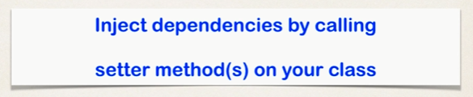

This is where the spring framework will inject the dependency by calling the setter methods in our class.

**Setter Injection (development process):**

1. Creating setter methods in our class for Injection.

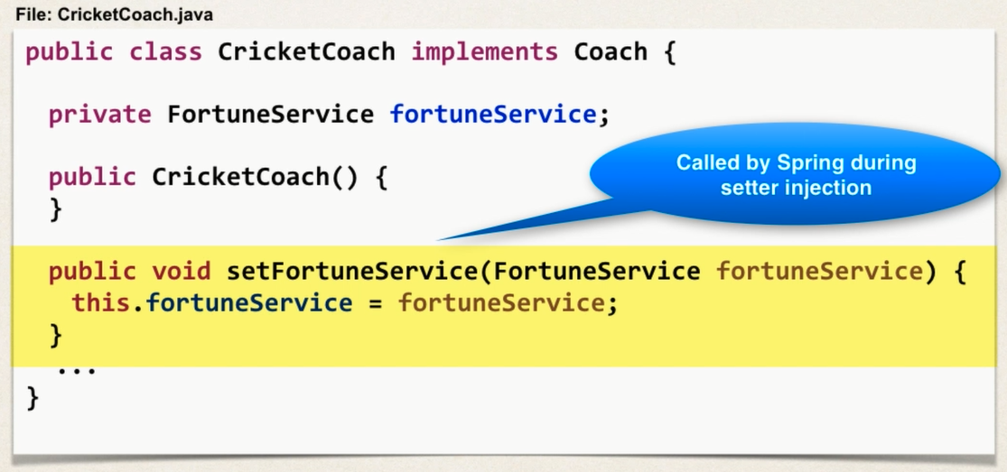

1. Configure the dependency injection in spring configuration file.

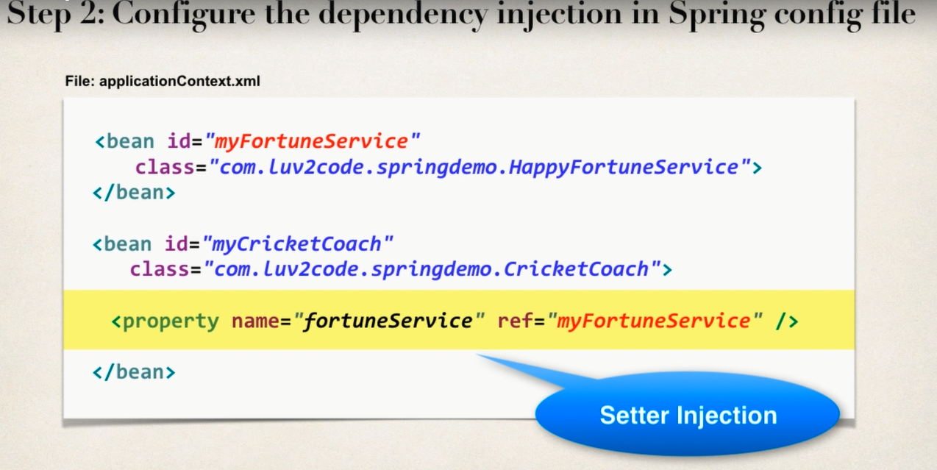

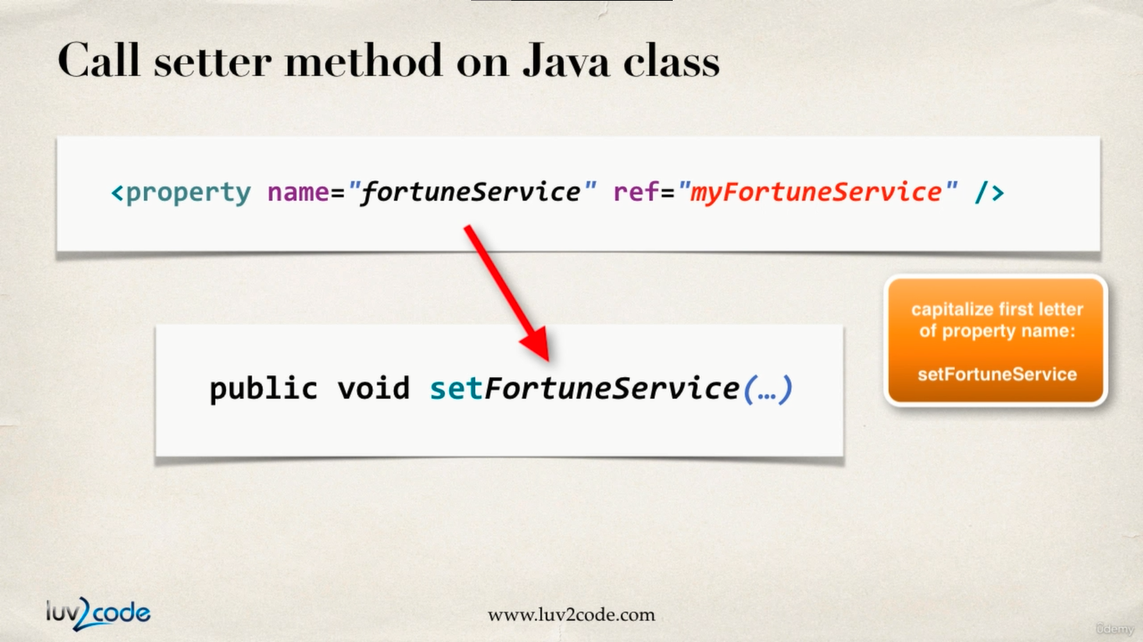

This is what happens in the background:

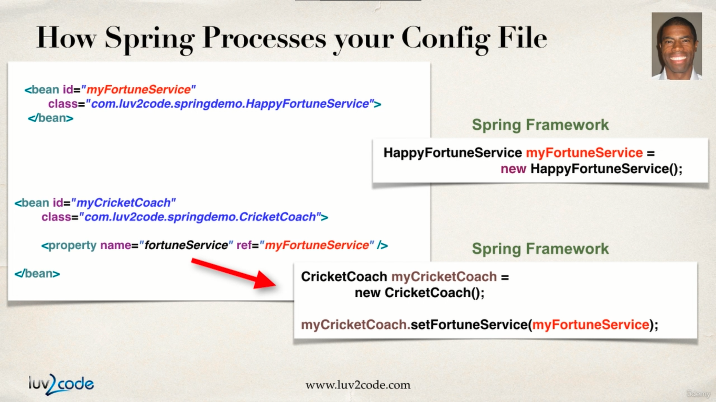

Here dependencies are installed by calling setter methods in our class. Consider the example below which describes

We will begin our code with creating one more class CricketCoach.java for demonstrating setter injection.

**Coach.java :**

**package** com.busybox.setterInjection;

**public** **interface** Coach {

**public** String getDailyWorkout();

**public** String getDailyFortune();

}

**BaseBallCoach.java**

**package** com.busybox.setterInjection;

**public** **class** BaseBallCoach **implements** Coach {

// define a private field for dependency

**private** FortuneService fortuneService;

**public** BaseBallCoach() {

}

// define a setter method for dependency injection

**public** **void** setFortuneService(FortuneService fortuneService) {

**this**.fortuneService = fortuneService;

}

@Override

**public** String getDailyWorkout() {

**return** "spend 30 minutes in batting practice";

}

@Override

**public** String getDailyFortune() {

// use the fortuneService to get fortune

**return** **this**.fortuneService.getFortune();

}

}

**TrackCoach.java :**

**package** com.busybox.setterInjection;

**public** **class** TrackCoach **implements** Coach {

// define a private field for dependency

**private** FortuneService fortuneService;

**public** TrackCoach() {

}

// define a setter method for dependency injection

**public** **void** setFortuneService(FortuneService fortuneService) {

**this**.fortuneService = fortuneService;

}

@Override

**public** String getDailyWorkout() {

**return** "Run a hard 5k";

}

@Override

**public** String getDailyFortune() {

// **TODO** Auto-generated method stub

**return** **this**.fortuneService.getFortune();

}

}

**CricketCoach.java :**

**package** com.busybox.setterInjection;

**public** **class** CricketCoach **implements** Coach {

FortuneService fortuneService;

**public** CricketCoach() {

}

**public** **void** setFortuneService(FortuneService fortuneService) {

**this**.fortuneService = fortuneService;

}

@Override

**public** String getDailyWorkout() {

// **TODO** Auto-generated method stub

**return** "bowl hard or Go HOME !!";

}

@Override

**public** String getDailyFortune() {

// **TODO** Auto-generated method stub

**return** fortuneService.getFortune();

}

}

**FortuneService.java :**

**package** com.busybox.setterInjection;

**public** **interface** FortuneService {

**public** String getFortune();

}

**HappyFortuneService.java :**

**package** com.busybox.setterInjection;

**public** **class** HappyFortuneService **implements** FortuneService {

@Override

**public** String getFortune() {

**return** "yes to your dreams !!";

}

}

**SetterInjectionDriver.java :**

**package** com.busybox.setterInjection;

**import** org.springframework.context.support.ClassPathXmlApplicationContext;

**public** **class** SetterInjectionDriver {

**public** **static** **void** main(String[] args) {

ClassPathXmlApplicationContext context = **new** ClassPathXmlApplicationContext(

"applicationContextSetterInjection.xml");

Coach trackCoach = context.getBean("myCoach", TrackCoach.**class**);

Coach baseballCoach = context.getBean("baseBallCoach", BaseBallCoach.**class**);

Coach cricketCoach = context.getBean("cricketCoach", CricketCoach.**class**);

System.***out***.println(trackCoach.getDailyWorkout()); // Run a hard 5k

System.***out***.println(trackCoach.getDailyFortune()); // yes to your dreams !!

System.***out***.println(baseballCoach.getDailyWorkout()); //spend 30 minutes in batting practice

System.***out***.println(baseballCoach.getDailyFortune()); // yes to your dreams !!

System.***out***.println(cricketCoach.getDailyWorkout()); // bowl hard or Go HOME !!

System.***out***.println(cricketCoach.getDailyFortune()); // yes to your dreams !!

context.close();

}

}

**applicationContextSetterInjection.xml :**

<?xml version=*"1.0"* encoding=*"UTF-8"*?>

<beans xmlns=*"http://www.springframework.org/schema/beans"*

xmlns:xsi=*"http://www.w3.org/2001/XMLSchema-instance"*

xmlns:context=*"http://www.springframework.org/schema/context"*

xsi:schemaLocation=*"http://www.springframework.org/schema/beans*

*http://www.springframework.org/schema/beans/spring-beans.xsd*

*http://www.springframework.org/schema/context*

*http://www.springframework.org/schema/context/spring-context.xsd"*>

<!-- Define your beans here -->

<!-- dependency bean -->

<bean id=*"myFortuneBean"*

class=*"com.busybox.setterInjection.HappyFortuneService"*></bean>

<bean id=*"myCoach"* class=*"com.busybox.setterInjection.TrackCoach"*>

<!-- setup setter injection -->

<property name=*"fortuneService"* ref=*"myFortuneBean"*></property>

</bean>

<bean id=*"baseBallCoach"*

class=*"com.busybox.setterInjection.BaseBallCoach"*>

<!-- setup setter injection -->

<property name=*"fortuneService"* ref=*"myFortuneBean"*></property>

</bean>

<bean id=*"cricketCoach"*

class=*"com.busybox.setterInjection.CricketCoach"*>

<!-- set up setter injection -->

<property name=*"fortuneService"* ref=*"myFortuneBean"*></property>

</bean>

</beans>

Injecting literals into class

In this section we will learn how to inject literal values into our spring objects.

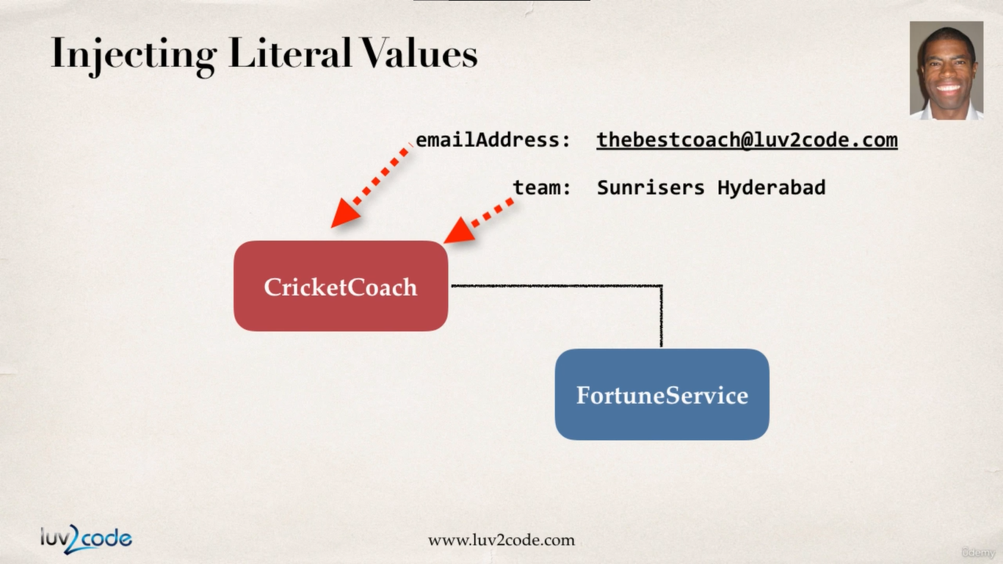

**Development Process :**

1. Create setter method in our class for injections

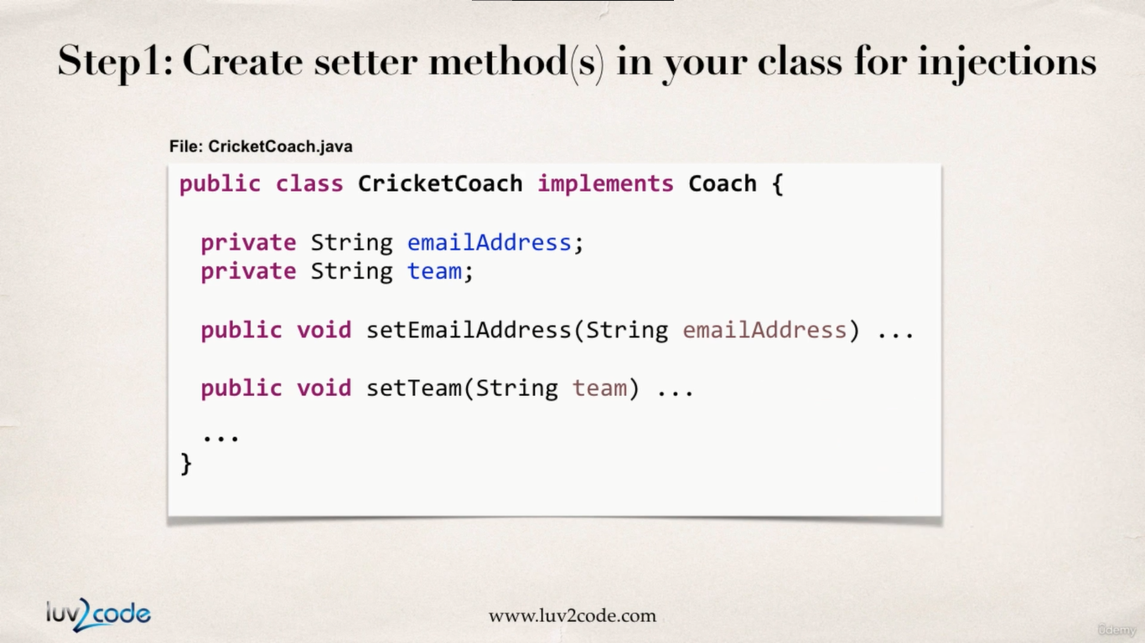

1. Configure the injection in the spring config file

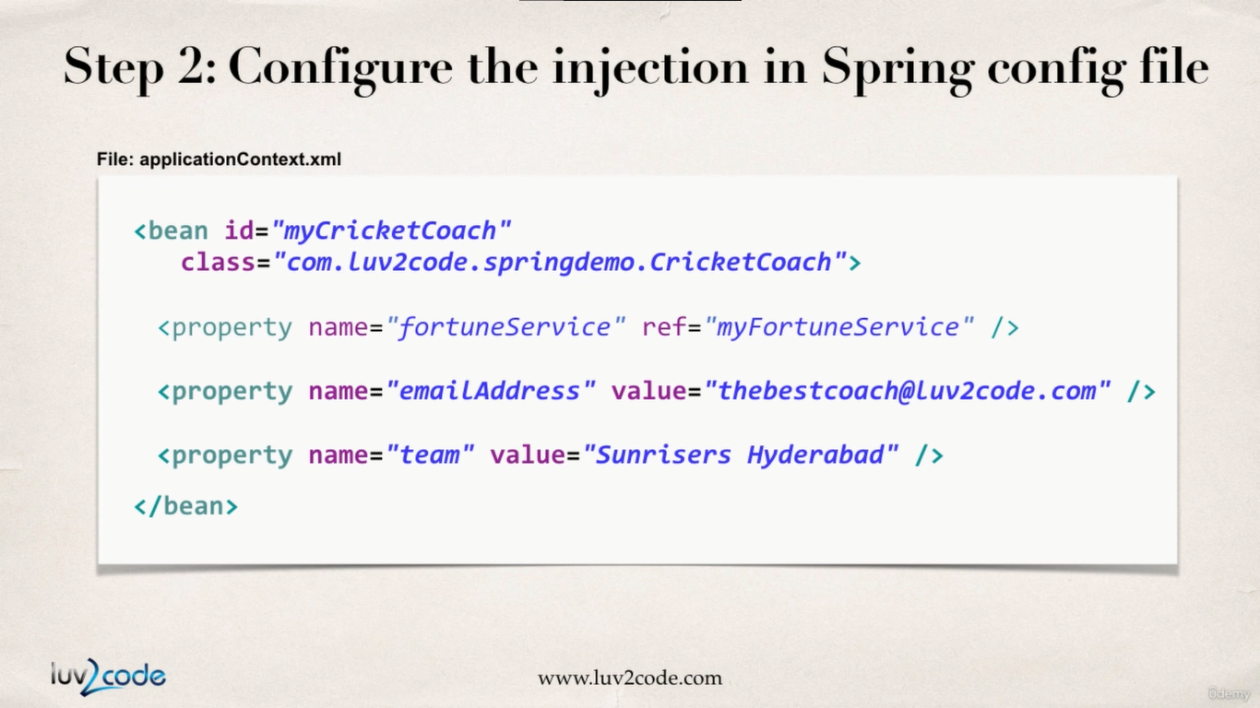

So in this example below we will be going to inject “emailAddress” and “phoneNumber” literal values into the **CricketCoach** spring object.

In order to implement this we need to add additional **<property/>** to **applicationContextSetterInjection.xml** file as shown below :

**applicationContextSetterInjection.xml :**

<?xml version=*"1.0"* encoding=*"UTF-8"*?>

<beans xmlns=*"http://www.springframework.org/schema/beans"*

xmlns:xsi=*"http://www.w3.org/2001/XMLSchema-instance"*

xmlns:context=*"http://www.springframework.org/schema/context"*

xsi:schemaLocation=*"http://www.springframework.org/schema/beans*

*http://www.springframework.org/schema/beans/spring-beans.xsd*

*http://www.springframework.org/schema/context*

*http://www.springframework.org/schema/context/spring-context.xsd"*>

<!-- Define your beans here -->

<!-- dependency bean -->

<bean id=*"myFortuneBean"*

class=*"com.busybox.setterInjection.HappyFortuneService"*></bean>

<bean id=*"myCoach"* class=*"com.busybox.setterInjection.TrackCoach"*>

<!-- setup setter injection -->

<property name=*"fortuneService"* ref=*"myFortuneBean"*></property>

</bean>

<bean id=*"baseBallCoach"*

class=*"com.busybox.setterInjection.BaseBallCoach"*>

<!-- setup setter injection -->

<property name=*"fortuneService"* ref=*"myFortuneBean"*></property>

</bean>

<bean id=*"cricketCoach"*

class=*"com.busybox.setterInjection.CricketCoach"*>

<!-- set up setter injection -->

<property name=*"fortuneService"* ref=*"myFortuneBean"*></property>

<!-- injection for email id literal value -->

<property name=*"emailAddress"* value=*"busyboxhere@gmail.com"*></property>

<!-- injection for phone number literal value -->

<property name=*"phoneNumber"* value=*"8847848036"*></property>

</bean>

</beans>

Then for setter injection we need to add Setter’s to our target class **CricketCoach.java** :

**CricketCoach.java**

**package** com.busybox.setterInjection;

**public** **class** CricketCoach **implements** Coach {

**private** FortuneService fortuneService;

**private** String phoneNumber;

**private** String emailAddress;

**public** CricketCoach() {

}

**public** **void** setFortuneService(FortuneService fortuneService) {

**this**.fortuneService = fortuneService;

}

**public** String getPhoneNumber() {

**return** phoneNumber;

}

**public** **void** setPhoneNumber(String phoneNumber) {

**this**.phoneNumber = phoneNumber;

}

**public** String getEmailAddress() {

**return** emailAddress;

}

**public** **void** setEmailAddress(String emailAddress) {

**this**.emailAddress = emailAddress;

}

@Override

**public** String getDailyWorkout() {

// **TODO** Auto-generated method stub

**return** "bowl hard or Go HOME !!";

}

@Override

**public** String getDailyFortune() {

// **TODO** Auto-generated method stub

**return** fortuneService.getFortune();

}

}

Now if we instantiate the above class in the driver class ( **SetterInjectionDriver.java** ), we will be able to print values with the help of getters.

**HelloSpringApp.java :**

**package** com.busybox.setterInjection;

**import** org.springframework.context.support.ClassPathXmlApplicationContext;

**public** **class** SetterInjectionDriver {

**public** **static** **void** main(String[] args) {

ClassPathXmlApplicationContext context = **new** ClassPathXmlApplicationContext(

"applicationContextSetterInjection.xml");

Coach trackCoach = context.getBean("myCoach", TrackCoach.**class**);

Coach baseballCoach = context.getBean("baseBallCoach", BaseBallCoach.**class**);

CricketCoach cricketCoach = context.getBean("cricketCoach", CricketCoach.**class**);

System.***out***.println(trackCoach.getDailyWorkout());

System.***out***.println(trackCoach.getDailyFortune());

System.***out***.println(baseballCoach.getDailyWorkout());

System.***out***.println(baseballCoach.getDailyFortune());

System.***out***.println(cricketCoach.getDailyWorkout());

System.***out***.println(cricketCoach.getDailyFortune());

System.***out***.println(cricketCoach.getEmailAddress()); // busyboxhere@gmail.com

System.***out***.println(cricketCoach.getPhoneNumber()); // 8847848036

context.close();

}

}

For the CricketCoach example with Setter Injection, why do we use the CricketCoach class instead of the

Coach interface?

The getTeam() method is only defined in the CricketCoach class. It is not part of the Coach interface.

As a result, you would need the following code:

    CricketCoach theCricketCoach = context.getBean("myCricketCoach", CricketCoach.class);

The Coach interface has two methods: getDailyWorkout and getDailyFortune

The CricketCoach class has four methods: getDailyWorkout, getDailyFortune, getEmailAddress and getPhoneNumber

When you retrieve a bean from the Spring container using the Coach interface:

    Coach theCricketCoach = context.getBean("myCricketCoach", Coach.class);

You only have access to the methods defined in the Coach interface: getDailyWorkout and getDailyFortune. Even though the actual implementation has additional methods, you only have visibility to methods that are defined at the Coach interface level.

---

When you retrieve a bean from the Spring container using the CricketCoach class:

    CricketCoach theCricketCoach = context.getBean("myCricketCoach", CricketCoach.class);

You have access to the methods defined in the Coach interface: getDailyWorkout and getDailyFortune.

ALSO, you have access to the additional methods defined in the CricketCoach class: getTeam, setTeam.

---

The bottom line is it depends on how you retrieve the object and assign it ... that determines the visibility you have to the methods.

Injecting values from a properties file

So far, we have learned how to inject literal values as dependency. So far, the injected values are hard coded in the **applicationContextSetterInjection.xml** file.

How ever, there is a way we can inject dependency from a properties file.

**Development Process :**

1. **create property file containing data**

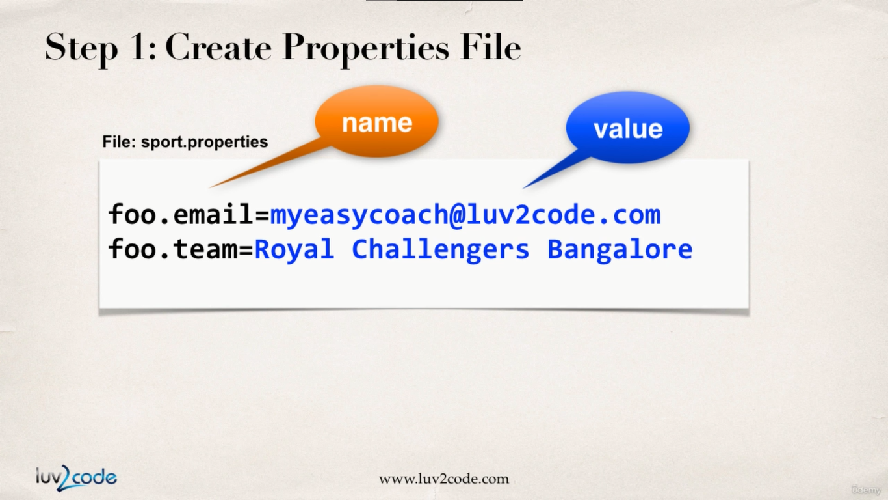

As a first step we will start with creating the “sport.properties” file. Always remember dont provide any quotes to the properties file to string values.

**sport.properties :**

emailAddress = anupamacharya25@gmail.com

phoneNumber = 8847848036

1. Load the Properties file in the spring config file

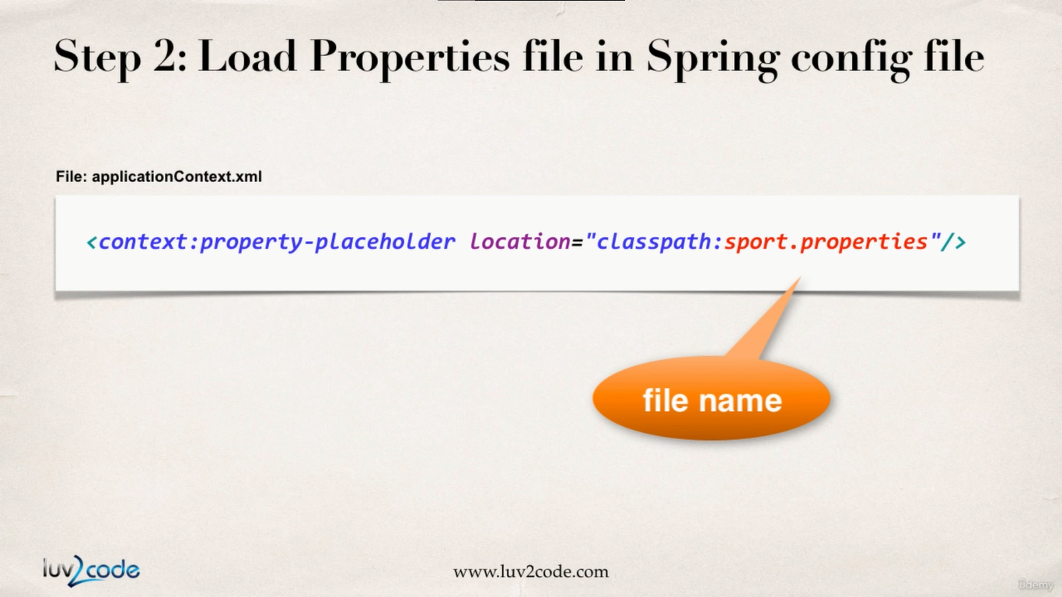

1. Reference values from properties file

Then we will reference the properties file from the applicationConfig.xml file and inject the dependency.

applicationContext.xml

<?xml version=*"1.0"* encoding=*"UTF-8"*?>

<beans xmlns=*"http://www.springframework.org/schema/beans"*

xmlns:xsi=*"http://www.w3.org/2001/XMLSchema-instance"*

xmlns:context=*"http://www.springframework.org/schema/context"*

xsi:schemaLocation=*"http://www.springframework.org/schema/beans*

*http://www.springframework.org/schema/beans/spring-beans.xsd*

*http://www.springframework.org/schema/context*

*http://www.springframework.org/schema/context/spring-context.xsd"*>

<!-- Define your beans here -->

<!-- dependency bean -->

<bean id=*"myFortuneBean"*

class=*"com.busybox.setterInjection.HappyFortuneService"*></bean>

<bean id=*"myCoach"* class=*"com.busybox.setterInjection.TrackCoach"*>

<!-- setup setter injection -->

<property name=*"fortuneService"* ref=*"myFortuneBean"*></property>

</bean>

<bean id=*"baseBallCoach"*

class=*"com.busybox.setterInjection.BaseBallCoach"*>

<!-- setup setter injection -->

<property name=*"fortuneService"* ref=*"myFortuneBean"*></property>

</bean>

<!-- load the property file -->

<context:property-placeholder

location=*"classpath:sport.properties"* />

<bean id=*"cricketCoach"*

class=*"com.busybox.setterInjection.CricketCoach"*>

<!-- set up setter injection -->

<property name=*"fortuneService"* ref=*"myFortuneBean"*></property>

<!-- injection for email id literal value -->

<!-- <property name="emailAddress" value="busyboxhere@gmail.com"></property> -->

<property name=*"emailAddress"* value=*"${emailAddress}"*></property>

<!-- injection for phone number literal value -->

<!-- <property name="phoneNumber" value="8847848036"></property> -->

<property name=*"phoneNumber"* value=*"${phoneNumber}"*></property>

</bean>

</beans>

As we can see the literal values are now reference with “${}” notation, where we access the key from the properties file.

Now as we make this injection in the “cricketCoach” bean, we will look at the corresponding class. This class follows setter injection.

**CricketCoach.java**

**package** com.busybox.setterInjection;

**public** **class** CricketCoach **implements** Coach {

**private** FortuneService fortuneService;

**private** String phoneNumber;

**private** String emailAddress;

**public** CricketCoach() {

}

**public** **void** setFortuneService(FortuneService fortuneService) {

**this**.fortuneService = fortuneService;

}

**public** String getPhoneNumber() {

**return** phoneNumber;

}

**public** **void** setPhoneNumber(String phoneNumber) {

**this**.phoneNumber = phoneNumber;

}

**public** String getEmailAddress() {

**return** emailAddress;

}

**public** **void** setEmailAddress(String emailAddress) {

**this**.emailAddress = emailAddress;

}

@Override

**public** String getDailyWorkout() {

// **TODO** Auto-generated method stub

**return** "bowl hard or Go HOME !!";

}

@Override

**public** String getDailyFortune() {

// **TODO** Auto-generated method stub

**return** fortuneService.getFortune();

}

}

And in the end, we call methods on our beans in “SetterInjectionDriver.java” file.

**package** com.busybox.setterInjection;

**import** org.springframework.context.support.ClassPathXmlApplicationContext;

**public** **class** SetterInjectionDriver {

**public** **static** **void** main(String[] args) {

ClassPathXmlApplicationContext context = **new** ClassPathXmlApplicationContext(

"applicationContextSetterInjection.xml");

Coach trackCoach = context.getBean("myCoach", TrackCoach.**class**);

Coach baseballCoach = context.getBean("baseBallCoach", BaseBallCoach.**class**);

CricketCoach cricketCoach = context.getBean("cricketCoach", CricketCoach.**class**);

System.***out***.println(trackCoach.getDailyWorkout());

System.***out***.println(trackCoach.getDailyFortune());

System.***out***.println(baseballCoach.getDailyWorkout());

System.***out***.println(baseballCoach.getDailyFortune());

System.***out***.println(cricketCoach.getDailyWorkout());

System.***out***.println(cricketCoach.getDailyFortune());

System.***out***.println(cricketCoach.getEmailAddress());

System.***out***.println(cricketCoach.getPhoneNumber());

context.close();

}

}

output :

Run a hard 5k

yes to your dreams !!

spend 30 minutes in batting practice

yes to your dreams !!

bowl hard or Go HOME !!

yes to your dreams !!

anupamacharya25@gmail.com

8093796383

Well in the context of dependency injection we saw a compilation error for missing default constructor for the classes we asked spring to instantiate. Well here is the answer :

When you don’t define any constructor in your class, compiler defines default one for you, however when you declare any constructor (in your example you have already defined a parameterized constructor), compiler doesn’t do it for you.

Since you have defined a constructor in class code, compiler didn’t create default one. While creating object you are invoking default one, which doesn’t exist in class code. Then the code gives an compilation error.